**ABSTRACT**

Ogauge pressure gauge is IIOT enabled device with connectivity to cloud services using Software as a service (SaaS) model. Ogauge pressure gauge sense the pressure as physical parameter

**INDEX**

|  |  |  |
| --- | --- | --- |
| Chapter | TITLE | PG NO |
| 1 | ABSTRACT | 3 |
| 2 | INTRODUCTION | 4 |
| 3 | HARDWARE DESCRIPTION | 5-7 |
| 4 | NETWORKING | 8-10 |
| 5 | OGAUGE INTEGRATION WITH PLC | 11 |
| 6 | SOFTWARE DEVELOPMENT | 12-13 |
| 7 | ADVANTAGES | 14 |
| 8 | PRECAUTIONS | 15 |
| 9 | APPLICATION | 16 |
| 10 | CONCLUSION | 17 |

**3. HARDWARE**

## **OGAUGE-**

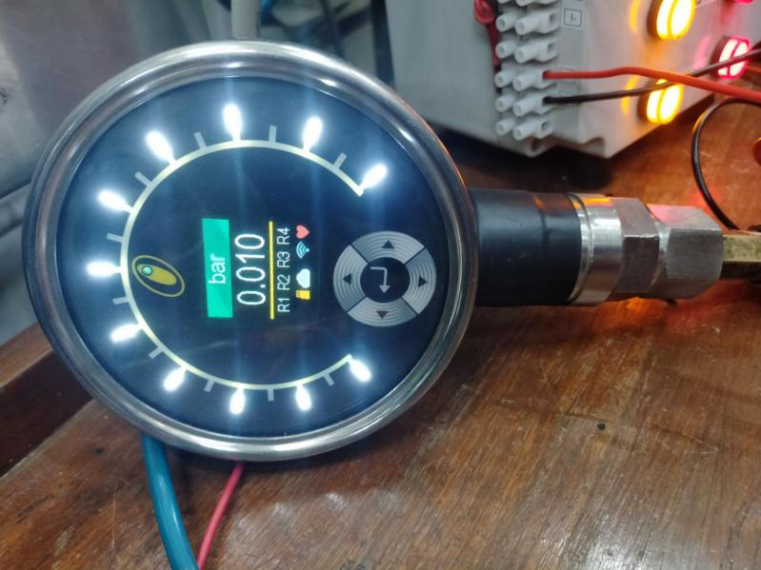

Ogauge pressure gauge is pressure measurement cell with OLED display and 4 switching controlled outputs, Cloud data storage, Easy configuration and Live data monitoring through Cloud-based dashboard at anytime and anyplace as well as Onboard diagnostics if any fault arises. This makes the gauge a completely Onboard data processing, communication and diagnostic transmitter.

Specifications:

* Measuring range: 10 mbar to 600 bars
* Power supply: 18-32 VDC
* Operating pressure: 1.5 times FSR (full scale reading)
* Tightening torque: 20nm
* Mechanical connection: 0.5” BSPM (British standard pipe measure)
* Relay outputs: 4

## **19 PIN connector with wire:**

PIN Configuration:

1. A, B: SUPPLY 24 DC INPUT 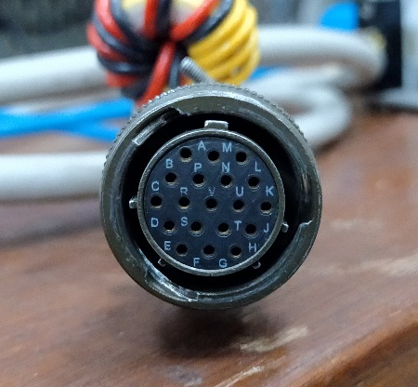
2. C, D: mA Current OUTPUT
3. E, F: Volt OUTPUT
4. G, H, J: Relay 1
5. K, L, M: Relay 2
6. N, P, R: Relay 3
7. S, T, U: Relay 4
8. V: Earth

## **RELAY INDICATION BLOCK**

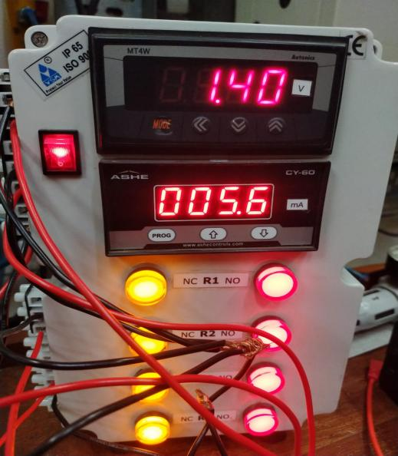

* For optimum Integration of Ogauge monitoring system, 2 analog outputs Voltage and current is also provided on separate dedicated display over Indication block.
* Within block there is SMPS (Switch Mode Power Supply) to convert AC power to regulated DC power supply for Ogauge.
* Also relay indicators are given over the block.

## **Micro 820 PLC**

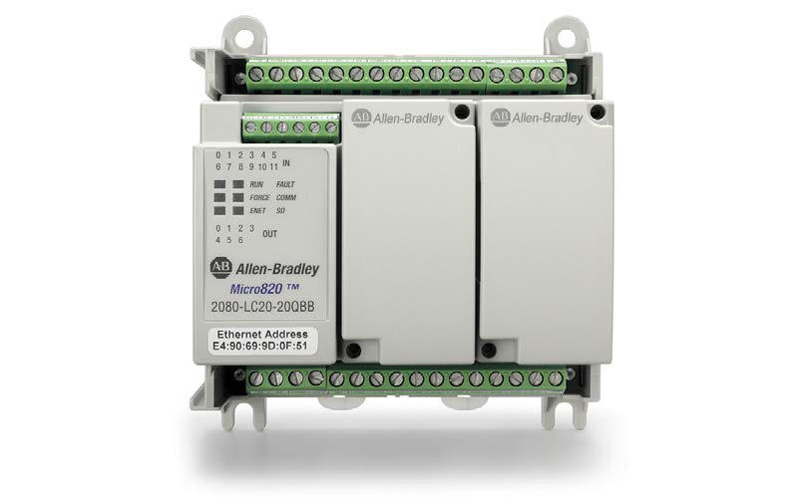

Micro 820 PLC is optimized for small standalone machines and remote automation projects. Ethernet / IP for Connected Components Workbench (CCW) programming, RTU applications and HMI connectivity. Built-in Real Time Clock (RTC) with no battery required microSD slot for program transfer, data log and recipe. Selected models available with removable terminal blocks for easier wiring and installation.

## **Specifications:**

* Power supply: 24VDC
* Programming port: Ethernet /IP port
* Max micro-SD card size: 32gb
* PWM output: 5 kHz
* Digital I/O: 12/7
* Analog I/O: 4/1
* Programming software: Connected Components Workbench (CCW)

## **Pin configuration:**

1. DC +10V 17. DC +24V(SUPPLY)
2. DC -24V 18. DC -24V(SUPPLY)
3. I-00 (AI/DI) 19. DC -24V
4. I-01 (AI/DI) 20. V0- 0 (AO)
5. I-02 (AI/DI) 21. NU
6. I-03 (AI/DI) 22. +CM0
7. COM0 23. O-00 (DO)
8. I-04 (DI) 24. O-01 (DO)
9. I-05 (DI) 25. O-02 (DO)
10. I-06 (DI) 26. O-03 (DO)
11. I-07 (DI) 27. -CM0
12. I-08 (DI) 28. +CM1
13. I-09 (DI) 29. O-04 (DO)
14. I-10 (DI) 30. O-05 (DO)
15. I-11 (DI) 31. O-06 (DO)
16. NU 32. -CM1
17. **NETWORKING:**

## **1.Registration of OGAUGE:**

1. Scanning the QR code
2. Entering the customer details (Name, contact, etc.)
3. Mail notification provided of Successful registered along with dashboard link.
4. Dedicated 2 MAC addresses of Ogauge gets visible on dashboard and Orion mobile app.
5. When it comes to any Private network zone, the corresponding MAC addresses are registered in the subsequent Private network.
6. Using Local Wi-Fi on the Private network, the gauge can then communicate with Cloud and communication is established.
7. Also, Bluetooth is used for communication with Smartphone Android app.

MAC address 1:

MAC address 2:

Firmware version 1: 0.21.45

Firmware version 2: 0.2.12

## **2.Dashboard Interface details:**

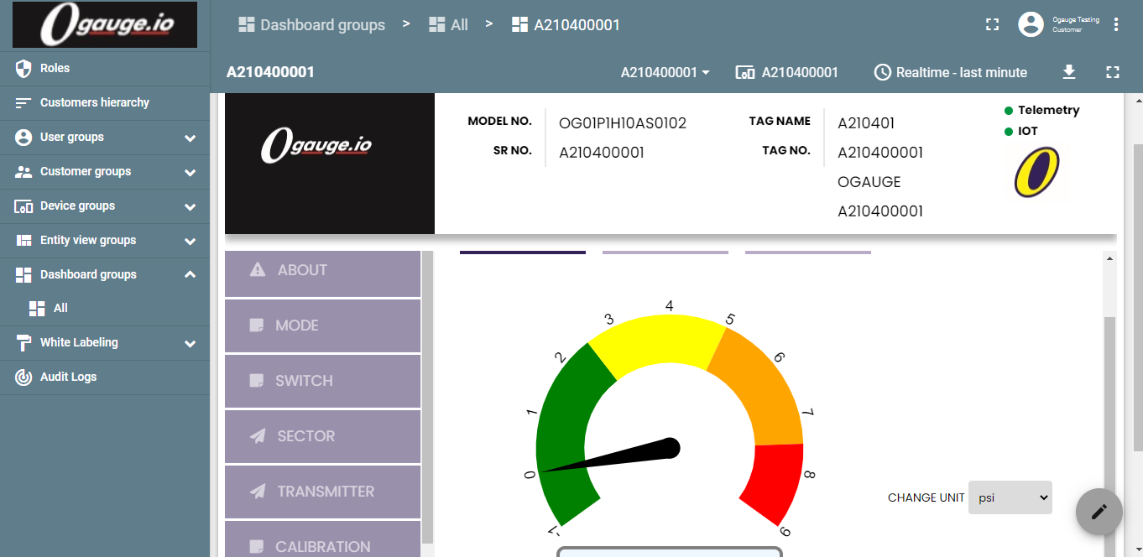

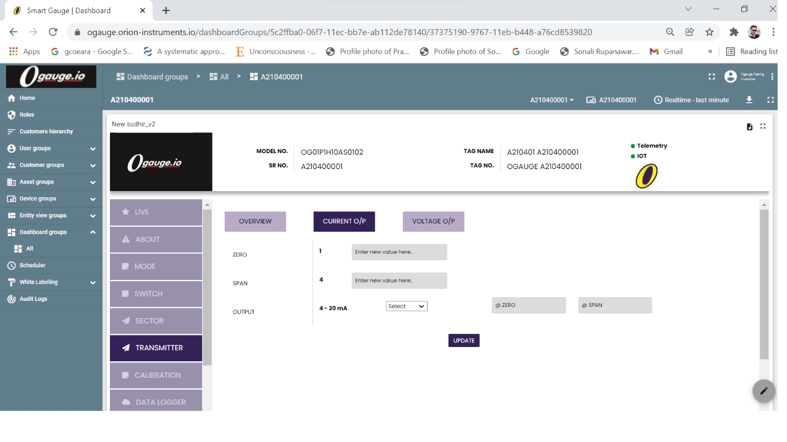

Key Blocks available on Dashboard:

1. User Interface can be created as per customer (Operator or Admin) needs.
2. Telemetry and IOT communication indicators are available to visualize communication.
3. DEVICE VIEW is for visualization of Real time data values.
4. LIVE GRAPH is for visualization of Real time data values in graphical format.
5. TREND ANALYSIS, Historical data is visualized and fetched in csv and xls file format.
6. SWITCH view is for setting up the Lower, Upper limits and delays of Switching relays.
7. SECTOR view is for setting up the graphical representation.
8. TRANSMITTER view is for setting up Zero, Span, Current, Voltage output standards.
9. CALIBRATION view is for setting reminder for next calibration.
10. DATA LOGGER view is for setting up data interval time for logging the data to cloud.
11. CLOUD CONNECT view is to manual ON/OFF WIFI and Telemetry data connectivity to cloud.

**3. Android app Orion Interface details:**

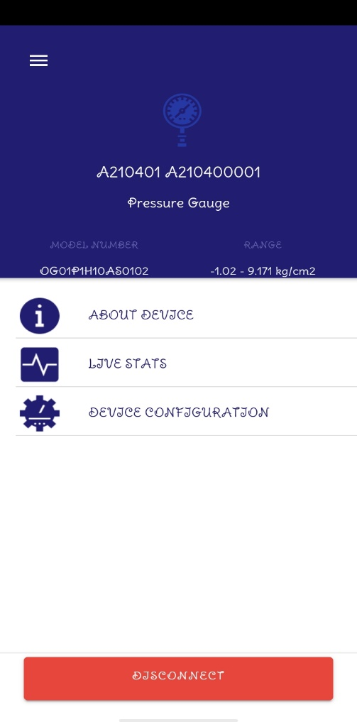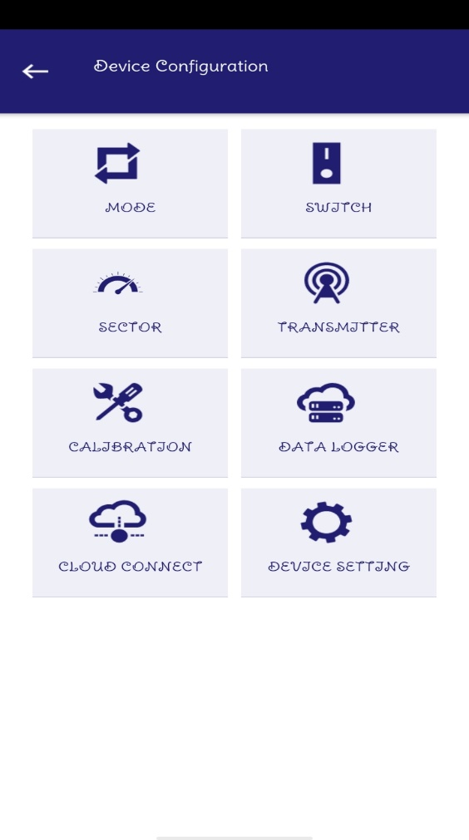

1. Using Mobile App, Mode of the Gauge can be changed to PRESSURE or LEVEL.
2. The Gauge can be calibrated with the use of MOBILE APP.
3. The Details regarding WIFI can be set using MOBILE APP.
4. The Feature which are provided to Dashboard are also made available to MOBILE APP.
5. **OGAUGE INTEGRATION WITH PLC:**

## **Steps for connecting hardware:**

1. Connect MICRO 820 to 24VDC through power supply box.
2. Connect RELAY INDICATION BLOCK to regular 230VAC power supply.
3. Connect I-O 4,5,6,7 to respective relay inputs of RELAY INDICATION BLOCK.
4. Connect the relay outputs of RELAY INDICATION BLOCK to GND pin of MICRO 820 PLC.
5. Create a Ladder logic program of relay activation on Connected Components Workbench.
6. Configure the driver of MICRO 820 PLC using dynamic IP address.
7. Upload the program in MICRO 820 PLC.
8. Change the pressure given to OGAUGE and check the relay operation.
9. Create SCADA diagram over FactoryTalk studio.
10. Configure to the same IP address communication.
11. Run over FactoryTalk studio.
12. **SOFTWARE DEVELOPMENT:**
    1. Connected Components Workbench (CCW)

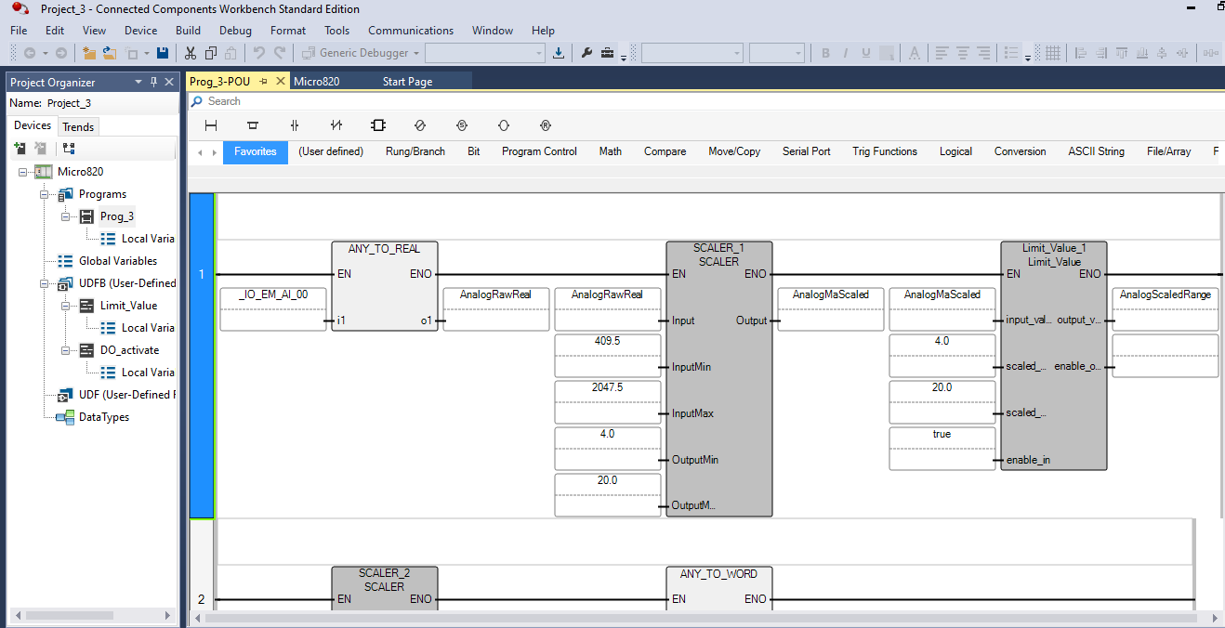

## **Ladder logic implementation:**

1. Using this software, we created a ladder logic for connecting Ogauge current/ voltage signals and relay signals to PLC.
2. So that we can actuate different Final control elements like switches, pumps in process plant to control process using Analog and Digital outputs of PLC.
3. For PLC analog input, the scale for 0-10 Volt signal is 0 to 4095 units.
4. So, for PLC analog signal coming from any device (in our case Ogauge) is taken as word.
5. Converting 1-5 V Ogauge signal (floating point values) to the PLC real value (409.5-2047.5 units integer value) using ANY_TO_REAL block.
6. Scaling the PLC real value (units) to 4-20 mA values using SCALER block.
7. Now, converting the 4-20 mA values to range of 0-9 bar using Limit_Value block.
8. Four relay signals of Ogauge are used as digital inputs of PLC to actuate four relay coils at output side to control the various process parameters.
9. As Relay switches NO to NC and vice-versa at lower and upper limit values of pressure, the PLC analyses it, performs ladder logic algorithm and gives output to the corresponding conditions.

4.2. FACTORYTALK STUDIO

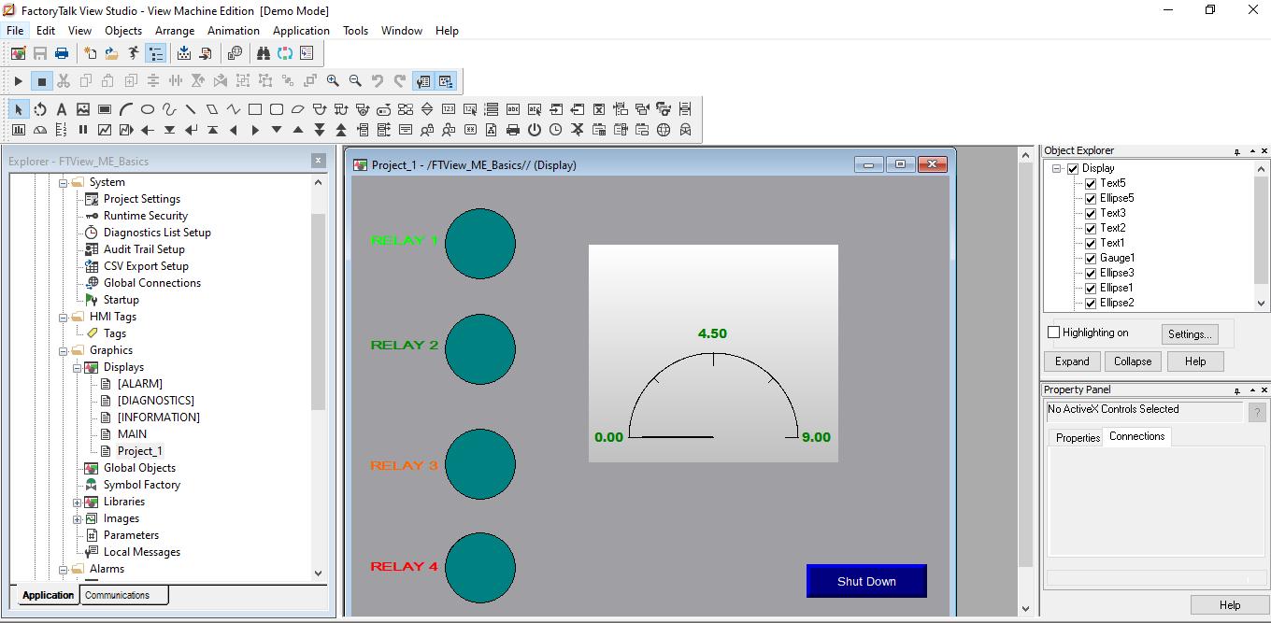

Using this software, we created SCADA environment for visual representation of Real time plant.

4.3. OGAUDE LIVE DASHBOARD ONLINE-

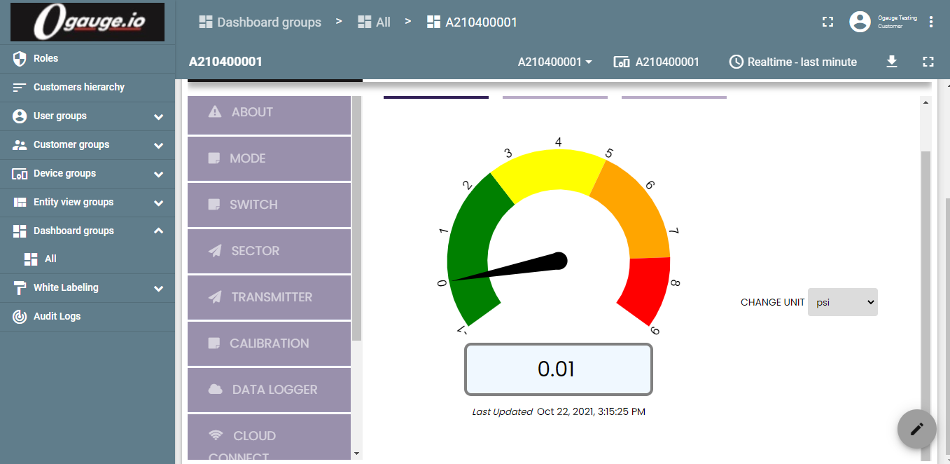

1. **CALIBRATION OF OGAUGE**
2. Re-ranging the Ogauge at 1-9 kg/cm2 zero span adjustment.
3. Collecting data of True value, observed value, Current and voltages with the same zero span values.
4. Repeating the above cycle 3 times
5. Collecting the above observations in rising and falling pattern 1 time.
6. Re-ranging the Ogauge at 4-6 kg/cm2 zero span adjustment.
7. Repeating steps 2 to 4 again with new zero span values.

**Observations:**

1. **Pressure at 1 – 9 kg/cm2 span zero settings**
2. We got an Average accuracy of 0.3185185185 and Linearity of 0.999998606
3. Hysteresis value was 0.05
4. **Pressure at 4 – 6 kg/cm2 span zero settings**
5. We got an Average accuracy of 2.560606061 and Linearity of 0.9996595982
6. Hysteresis value was 0.0038
7. **ADVANTAGES:**
8. Real time data conversion and Cloud data storage.

2) No separate data processing transducer required.

3) Makes communication between user and site of plant.

4) It gives Live monitoring using Cloud-based dashboard.

5) Indicates failure and performs diagnostic from anyplace anytime.

**9. PRECAUTIONS**:

1. Connection should be proper and tight.

2. Use components within a range.

3. Should provide required source voltage.

4. Proper internet connection required.

**9. APPLICATIONS:**

1) For real time monitoring and Online diagnostics of OGAUGE pressure gauge at anytime and anywhere.

10. **CONCLUSION**

We have got all the relay operations and indications as per set limits of pressure data being measured on plant site. We also got live readings over the Cloud-based dashboard set for the SMART OGAUGE.